ABU LIBRARY COMPLEX BULLETIN
MONTHLY BULLETIN VOLUME: Vol. 3 No. 3 MONDAY, 8TH JUNE 2015

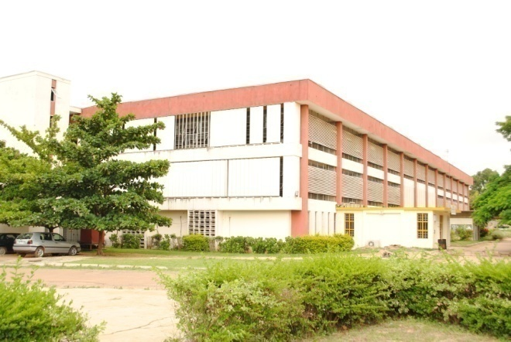

PROFESSIONAL CODE OF ETHICS FOR LIBRARIANS
As members of a professional society, Librarians recognize the importance of codifying and making known to the profession and to the general public the ethical principles that guide the provision of information services. This code is an excerpt from the IFLA code of Ethics for Librarians and other Information Workers.
Access to information: the core mission of Librarians is to ensure access to information through the provision of the highest level of service to all library costumers.
Responsibility towards individuals and society: Librarians ensure that equitable services are provided to everyone irrespective of their age, physical or mental ability, gender, socio-economic or marital status, state of origin, religion or political beliefs.
Privacy, secrecy and transparency: Librarians respect and protect each library costumer's right to privacy and confidentiality with respect to information sought or received and resources consulted or borrowed.
Open access and intellectual property: Librarians have a professional duty to provide the best possible access to information in any media or format. They also recognize the intellectual property rights of authors and ensure these rights are respected.
Professional development: Librarians strive for excellence in the profession by enhancing their own knowledge and skills through training, conferences, workshops and further education.
Colleague and employer/employee relationship: Librarians treat co-workers and other colleagues with respect, fairness and good faith, and advocate

conditions of employment that safeguard the rights and welfare of all employees of their institutions. Librarians also share their professional experience with colleagues.__________________________
OFFICE OF THE UNIVERSITY LIBRARIAN
Abdullahi I. Musa is the Interim University Librarian of Ahmadu Bello University Zaria Library Services. Musa graduated with a doctorate degree in Library & Information Management (Information Systems Concentration) from Emporia State University Kansas, United States.
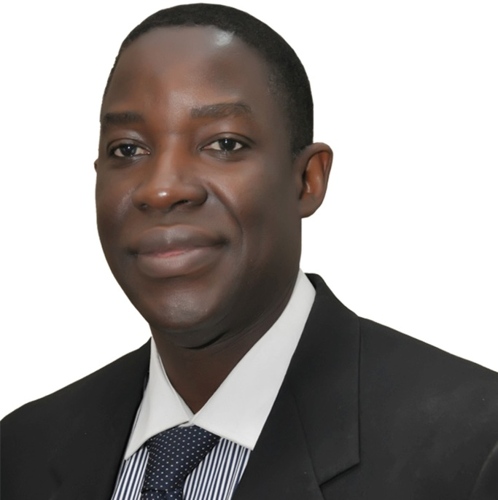
Ag University Librarian
Abdullahi I. Musa, PhD (Emporia, USA)
Dr Abdullahi was at various times a visiting Scholar with the University of Illinois Graduate School of Library and Information Science (GSLIS) USA, Emporia State University Kansas, and The Mortenson Center for International Library Programs at the University of Illinois at Urbana-Champaign. He has taught courses in information studies in the United States and Nigeria and is a recipient of many awards and scholarships for academic excellence._____________________
GETTING ACQUINTED WITH THE ABU LIBRARY COMPLEX SERIES 4
This is the 4th in the series “Getting acquainted with ABU Library Complex.” Our focus is on Research and Bibliographic Services Division (RBSD), Kashim Ibrahim Library.
RESEARCH AND BIBLIOGRAPHIC SERVICES DIVISION
This division, as the name implies, is the main research section of Kashim Ibrahim Library, comprising of the Africana and Theses unit, Arabic unit and Documents unit. These units stock and maintain resources for research in closed access.
Africana and Theses Unit: Holds resources on Africa, Africans, and Africans in Diaspora. Its stock is heavily enriched with the inclusion of the Clarence Holte Collection which was purchased by the university when the African – Africana bibliophile Clarence Holte, brought his lifelong collection of printed materials on the Black race for exhibition at FESTAC 1977. Almost every subject is represented in the collection. The Theses side of the unit stocks (mainly) theses and dissertations produced in Ahmadu Bello University, and a few others by A.B.U. personnel who obtained their postgraduate degrees from other universities. This unit is also in charge of allocating study carrels to individual researchers on request.
Arabic Unit: Stocks Arabic language resources on various subjects, exclusively for research and strictly on demand.
Documents Unit: Holds publications of Ministries, Departments and Agencies at Federal and state levels. Its collection on these dates back to the colonial era as government reports and gazettes are included. It is the unit that stocks publications of various kinds of the United Nations, our library having been designated a U.N. depository since the 1960’s. These publications include those from its agencies like WHO, FAO, UNDP, UNICEF, UNESCO, etc.___________________________
ABOUT THE HEAD OF RBSD
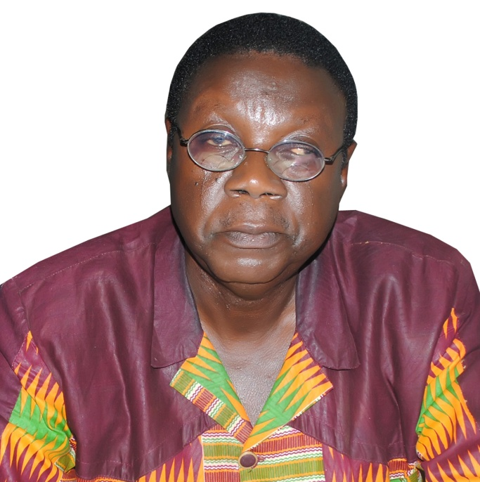
MR. TSUZOM M. NDAKOTSU
The current head of the division is Mr. Tsuzom M. Ndakotsu, a long time library professional who is very well acquainted with the division having served, on his up, as head of Africana and Documents units. This is his second tenure as head of division, as in between he has served as librarian in key satellite libraries-Agricultural library, President Kennedy Library, and the Division of Agricultural Colleges Library.
Mr. Ndakotsu holds a Bachelor of Library Science (BLS), Master of Library Science (M.L.S.) and Master of Arts (M.A.) in African Literature, evidence of his intellectual scholarship inclination. He is currently working on his doctorate. He has researched and published a good number of articles in reputable academic and professional journals and has many seminar and conference papers to his credit.
He is a Chartered Librarian of Nigeria (CLN), Member of the Chartered Institute of Library and Information Professionals U.K., (CILIP) (MCLIP) and a member of the Chartered Institute of Administration (MCIA).____________________
STAFF OF THE MONTH
MISS HAUWA JAMES-EGOH
Library Assistant
Hauwa is a staff of RBSD. She is a very hardworking, customer friendly, dedicated and reliable staff.
She joined the services of the University in 2012. This month (like any other time), Hauwa is being recognized for her consistency and contributions.
Media & Public Relations Division, KIL – Here to serve you www.abu.edu.ng/library

